Link : https://github.com/intuit/karate

- Karate Dependency.
<!-- https://mvnrepository.com/artifact/com.intuit.karate/karate-junit4 -->

Maven
Karate is designed so that you can choose between the Apache or Jersey HTTP client implementations.
So you need two <dependencies>:
<dependency>
<groupId>com.intuit.karate</groupId>
<artifactId>karate-apache</artifactId>
<version>0.7.0</version>
<scope>test</scope>
</dependency>
<!-- https://mvnrepository.com/artifact/com.intuit.karate/karate-junit4 -->

<dependency>
<groupId>com.intuit.karate</groupId>
<artifactId>karate-junit4</artifactId>
<version>0.7.0</version>
<scope>test</scope>
</dependency>
And if you run into class-loading conflicts, for example if an older version of the Apache libraries are being used within your project - then use karate-jersey instead of karate-apache.
#################################################################

TestNG instead of JUnit
If you want to use TestNG, use the artifactId karate-testng. If you are starting a project from scratch, we strongly recommend that you use JUnit. Do note that dynamic tables, data-driven testing and tag-groups are built-in to Karate, so that you don't need to depend on things like the TestNG @DataProvider anymore.
Use the TestNG test-runner only when you are trying to add Karate tests side-by-side with an existing set of TestNG test-classes, possibly as a migration strategy. One of the things you would miss if you use TestNG is the JUnit HTML report that is very useful for troubleshooting tests in dev-mode.

In addition, the “Getting Started” guide for Karate recommends using jUnit — NOT TestNG — since things like dynamic tables, data-driven testing and tag groups are already built in.

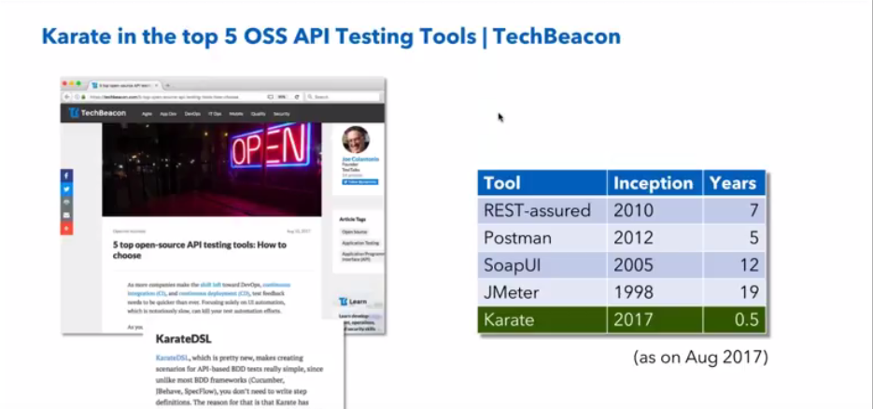

Karate scripts are technically in 'Gherkin' format - but all you need to grok as someone who needs to test web-services are the three sections: Feature, Background and Scenario. There can be multiple Scenario-s in a *.feature file, and at least one should be present. The Background is optional.

Note : Lines that start with a # are comments.

Feature: brief description of what is being tested
more lines of description if needed.

Background:
# this section is optional !
# steps here are executed before each Scenario in this file
# variables defined here will be 'global' to all scenarios
# and will be re-initialized before every scenario

Scenario: brief description of this scenario
# steps for this scenario

Scenario: a different scenario
# steps for this other scenario

Core Keywords
They are url, path, request, method and status.
Given url 'https://myhost.com/v1/cats'
A URL remains constant until you use the url keyword again, so this is a good place to set-up the 'non-changing' parts of your REST URL-s.

web-services by nature are "headless", without a UI, and not really human-friendly.

Under src/test/java, create a new file called Jenkins.feature

